Summer2025:
You are asked to implement part of a Hashtable class where the keys are integers and the values are strings. The class has an array of Node type named ht, which is considered the hashtable. You have to write the class method insert, which should insert a new key-value pair in the hashtable.
The class method hash(key) method computes the hash index based on the key and returns the index of the hashtable. This method is already written for you. You shall use this while inserting a key-value pair.
While inserting, if there's any collision, you should follow the separate chaining approach; however, you should make sure that the nodes are added in ascending order of the keys.
If there's any duplicate key, replace the previous value of that corresponding key. (Update code)
Make sure that the time complexity of your code is O(n)
The Node class (non-dummy-headed singly type) for the hashtable is already implemented with key (int), val (String), and next (Node) variables. You do not need to write it.
Initial Hashtable ht | After executing insert (5,"RAT")--  Assume, key 5’s calculated index is 4
Index 0: (3, CAT) -> (4, EELS)  Index 1: (5, LION)  Index 2: (2, DOG) -> (9, CROW)  Index 3: (27, WOLF)  Index 4: (10, FISH) -> (11, OWL) | Index 0: (3, CAT) -> (4, EELS)  Index 1: (5, LION)  Index 2: (2, DOG) -> (8, GOAT) -> (9, CROW)  Index 3: (27, WOLF)  Index 4: (5,"RAT") -> (10, FISH) -> (11, OWL)
Initial Hashtable ht | After executing insert(8,"GOAT")--  Assume, key 8’s calculated index is 2
Index 0: (3, CAT) -> (4, EELS)  Index 1: (5, LION)  Index 2: (2, DOG) -> (9, CROW)  Index 3: (27, WOLF)  Index 4: (5,"RAT") -> (10, FISH) -> (11, OWL) | Index 0: (3, CAT) -> (4, EELS)  Index 1: (5, LION)  Index 2: (2, DOG) -> (8, GOAT) -> (9, CROW)  Index 3: (27, WOLF)  Index 4: (5,"RAT") -> (10, FISH) -> (11, OWL)
(2, DOG) -> (8, GOAT) -> (9, CROW) | After executing insert(9,"BAT")--  Assume, key 9’s calculated index is 2
Index 0: (3, CAT) -> (4, EELS)  Index 1: (5, LION)  Index 2: (2, DOG) -> (8, GOAT) -> (9, CROW)  Index 3: (27, WOLF)  Index 4: (5,"RAT") -> (10, FISH) -> (11, OWL) | Index 0: (3, CAT) -> (4, EELS)  Index 1: (5, LION)  Index 2: (2, DOG) -> (8, GOAT) -> (9, BAT)  Index 3: (27, WOLF)  IIndex 4: (5,"RAT") -> (10, FISH) -> (11, OWL)
Use the variable named “ht” to access the hashtable inside the method insert.
# Python notation  def hash(key):  # use this function  # already written  def insert(key, value):  # Write your code here | // Java notation  int hash(int key){  // use this function  // already written  }  void insert(int key, String value){  // Write your code here  }

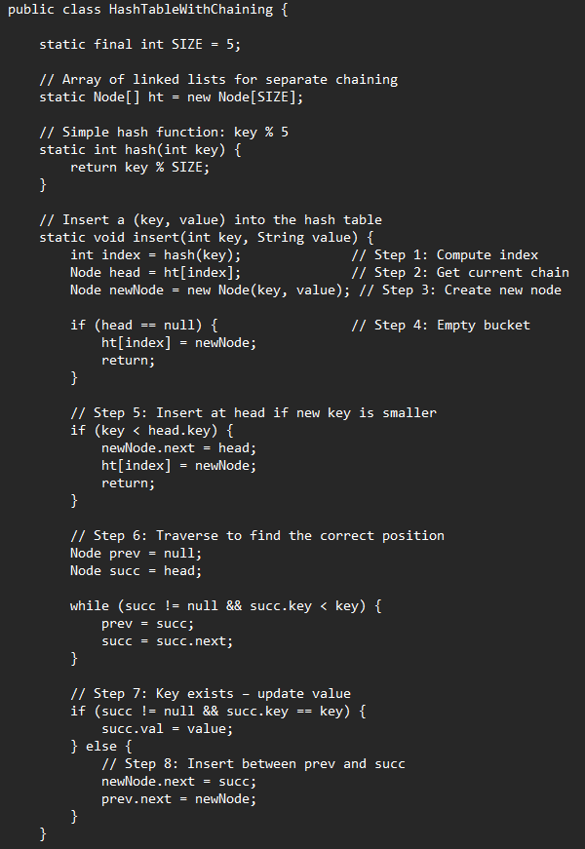

Hashing Theory Sample Questions:
I. A hash table of size 10 is used to store the following keys: 15, 25, 35, 45, 55, 65, 75.
Assume forward chaining will be used for collision handling.
Following four hash functions are proposed:
H1(k) = k mod 10 | H2(k) = (k / 10) mod 10 | H3(k) = (k + 5) mod 10 | H4(k) = (k * 2) mod 10
All the results will be in integer, if there are fractions the floor value is considered.
Which hash function is the best choice here to reduce the collision? [1 mark]
(a) H1 (b) H2 (c) H3 (d) H4
_______________________________________________________________________________________

Given keys:
15, 25, 35, 45, 55, 65, 75
_______________________________________________________________
H1(k) = k mod 10
15 → 15 % 10 = 5
25 → 25 % 10 = 5
35 → 35 % 10 = 5
45 → 45 % 10 = 5
55 → 55 % 10 = 5
65 → 65 % 10 = 5
75 → 75 % 10 = 5
Since all the keys end with 5, all of them produce the same hash value, 5.
So, all keys will be stored at index 5 using forward chaining.
➡️ All go to index 5 → worst collision
==============================================
H2(k) = (k / 10) mod 10, Here, integer division is used, so fractions are ignored.
15 → (15 / 10) % 10 = 1 % 10 = 1
25 → (25 / 10) % 10 = 2 % 10 = 2
35 → (35 / 10) % 10 = 3 % 10 = 3
45 → (45 / 10) % 10 = 4 % 10 = 4
55 → (55 / 10) % 10 = 5 % 10 = 5
65 → (65 / 10) % 10 = 6 % 10 = 6
75 → (75 / 10) % 10 = 7 % 10 = 7

➡️ Each key produces a different hash value. All go to different indices → no collision ✅
================================================
H3(k) = (k + 5) mod 10
15 → (15 + 5) % 10 = 20 % 10 = 0
25 → (25 + 5) % 10 = 30 % 10 = 0
35 → (35 + 5) % 10 = 40 % 10 = 0
45 → (45 + 5) % 10 = 50 % 10 = 0
55 → (55 + 5) % 10 = 60 % 10 = 0
65 → (65 + 5) % 10 = 70 % 10 = 0
75 → (75 + 5) % 10 = 80 % 10 = 0
➡️ All keys go to index 0 → worst collision.
================================================
H4(k) = (k × 2) mod 10
15 → (15 × 2) % 10 = 30 % 10 = 0
25 → (25 × 2) % 10 = 50 % 10 = 0
35 → (35 × 2) % 10 = 70 % 10 = 0
45 → (45 × 2) % 10 = 90 % 10 = 0
55 → (55 × 2) % 10 = 110 % 10 = 0
65 → (65 × 2) % 10 = 130 % 10 = 0
75 → (75 × 2) % 10 = 150 % 10 = 0
➡️ All keys go to index 0 → worst collision.
================================================
Answer: (b) H2
_______________________________________________________________________________________
Q4A For the hash table shown below, what is a possible sequence in which the key-value pairs are inserted?
(Hash Function = key % hash table length)
Hash Table:
0: (12, A), (8, D)
1: (9, B)
2: (6, M), (14, N)
3: Null

The insertion sequence is given below. Options
a) [inserted first](8, D), (12, A), (9, B), (6, M), (14, N) [inserted last]
b) [inserted first](12, A), (6, M), (14, N), (8, D), (9, B) [inserted last]
c) [inserted first](14, N), (9, B), (6, M), (8, D), (12, A) [inserted last]
d) [inserted first](14, N), (9, B), (6, M), (12, A), (8, D) [inserted last]

Answer: c) (14, N), (9, B), (6, M), (8, D), (12, A)
Explanation: Assuming prepend insertion is used in chaining, the most recently inserted item appears at the front of the chain.

Hash table length = 4, so:

Index 0:
12 % 4 = 0 and 8 % 4 = 0
Final chain: (12, A), (8, D)
So, (8, D) must be inserted before (12, A).

Index 2:
6 % 4 = 2 and 14 % 4 = 2
Final chain: (6, M), (14, N)
So, (14, N) must be inserted before (6, M).

Only option c satisfies both conditions.

Q5A Your two friends propose the following hash functions to map integer keys into a hash table of length n:
- Friend 1’s hash function: key * 2 % n, which means (key * 2) % n
- Friend 2’s hash function: key % (n/2)
Being a student who learned HashTable data structure, evaluate the two functions and find out:
(a) What is the potential problem (if any) with Friend 1’s hash function?
(b) What is the potential problem (if any) with Friend 2’s hash function?
Provide a one-line answer for each part.

Answers
(a) Friend 1: (key * 2) % n
This function has a potential problem when n is even. Since key * 2 is always even, the hash values will only fall in even indices.
For example, if n = 10:
(key * 2) % 10 can produce only: 0, 2, 4, 6, 8
Thus, odd indices remain unused, which wastes part of the hash table and increases collisions. However, if n is odd, this problem may not occur.
(b) Friend 2: key % (n/2)
This function wastes half of the hash table because the hash values can only fall within the first n/2 indices.
For example, if n = 10:
key % 5 can produce only: 0, 1, 2, 3, 4
Thus, indices 5, 6, 7, 8, 9 remain unused, which increases collisions.
======================================================================

Summer 2025:
In terms of memory consumption, which one do you think performs better between a linked list and a hashtable using forward chaining as collision handling? Briefly justify your answer in terms of space complexity.

Answer: A linked list performs better in terms of memory consumption.
Explanation:
A linked list only stores the data nodes, so for n elements: Space complexity = O(n)
A hash table with forward chaining stores:
- the hash table array of size m
- the linked-list nodes for n key-value pairs
So its space complexity is: Space complexity = O(m + n)
Therefore, in terms of memory consumption, a linked list is more memory-efficient.

